Formal Lab Report: Sample B
Lexi Marks
GTA: Dominic Fico
CHEM 2081-004

Introduction
For this lab report, the goal is to figure out the identity of an unknown sample (sample B). To find out what the identity of the unknown sample is, multiple tests must be conducted including NMR, FTIR, and MS. Through these tests, it is possible to learn more about the samples being used and learn more about the properties within the samples.
Body
NMR (also known as Nuclear Magnetic Resonance Spectroscopy) is a type of analysis that allows the understanding of a compound’s arrangement of atoms. The testing allows for the understanding of a compound’s molecular structure and dynamics by taking a look into the frequencies of signals coming from each molecule, allowing more into details about how the atoms work within the compound. An important goal for this type of testing is to understand a compound’s particular shape and how its shape affects the actions within the molecule.
FTIR (also known as Fourier Transform Infrared Spectroscopy) analysis is used to test a compound’s structure by including its shape and chemical properties while seeing what would happen if used with infrared light. The wavelengths from the infrared light come into the molecule to let off frequencies caused by the light to show more information about the compound just by seeing how its properties reacts with the infrared light. The infrared light becomes absorbed by the compound letting it show its unique qualities and what makes that compound significant from other compounds to help identify it better. The way that the frequencies come off shows distinction of the compound through a spectrum, making it known what the identity of a sample known. The testing can show properties like how the compound is bonded and functional groups that are included within the sample.
MS (also known as Mass Spectrometry) is a type of analysis that looks into a compound’s mass to help identify the compound’s name and properties. The testing goes through multiple processes to learn about the compound’s identity including ionization, mass analysis, and detection. Through ionization, the compound will gain charge to create a ratio using the mass and charge of the sample. A spectrum is created using the different ratios that allows the structure of the sample to become known. MS is a very important tool to help identify unknown samples with multiple steps to achieve that goal.
Data
NMR
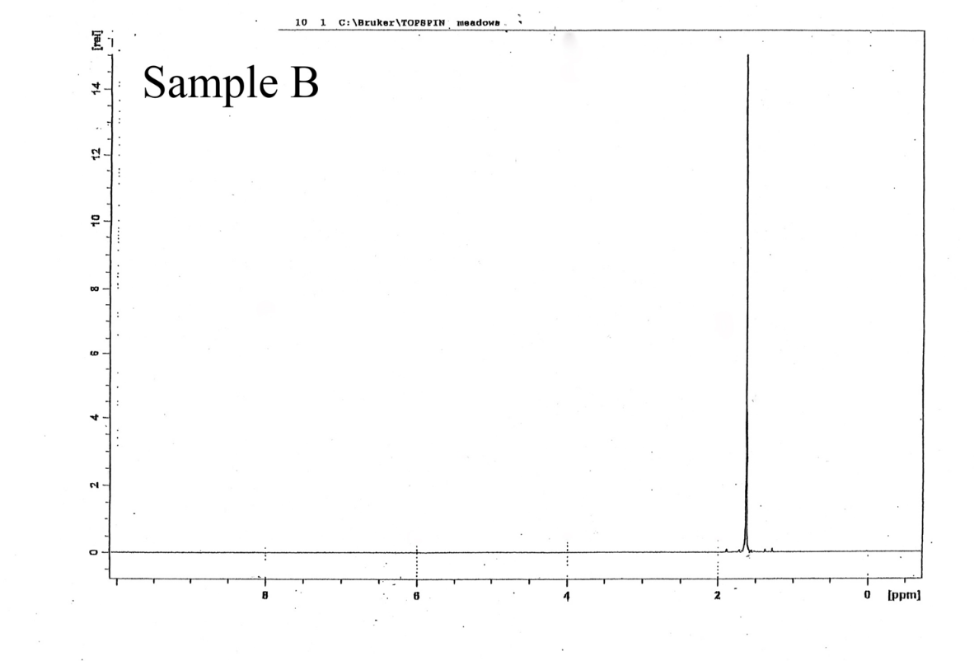

NMR
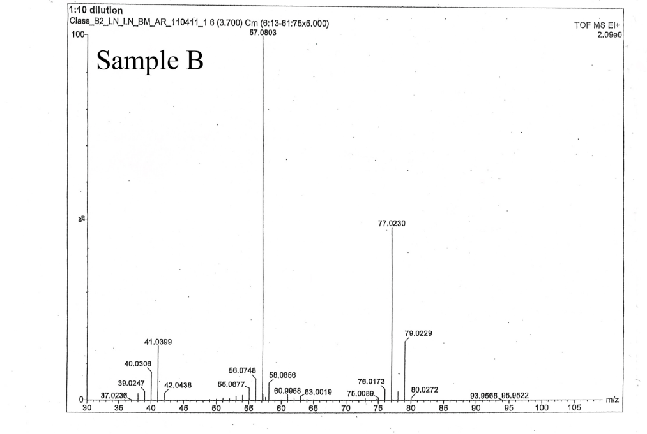
GCMS
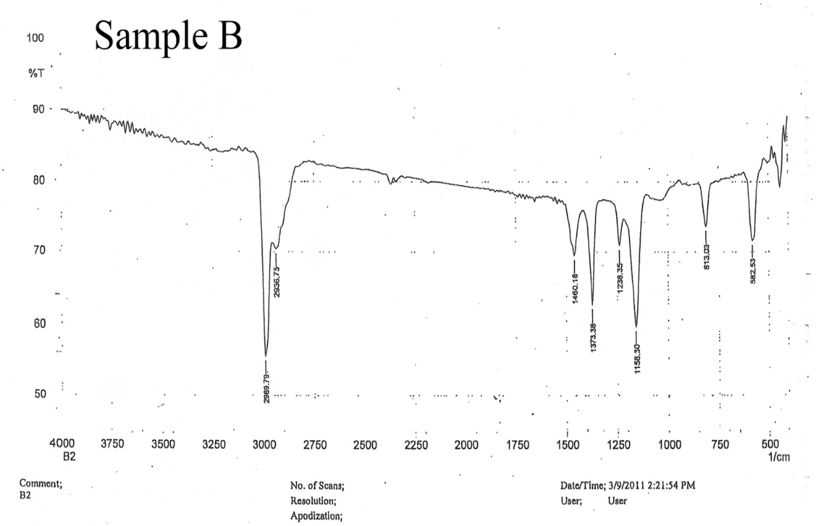
Analysis
Using the information from the NMR test, the test indicates information that can help learn more about the arrangement of atoms within the compound. The sample shows there to be one major spike in the graph, making known that there is only one particular type of proton in the compound with only one particular signal to give off. The spike is represented around the 1.6 ppm mark with a chlorine group being visible and signaling going down.
The MS (mass spectrometry) is used to determine chemical properties while looking into the mass of the compound. There are two types of peaks to be looking at when it comes to MS testing: base and molecular peaks. The base peak is the largest peak in the testing and is at 57.0803 m/z. The molecular peak is the biggest peak found within the testing, and it is 93.9566 m/z. The peaks help clarify that chlorine is part of the unknown compound by subtracting the base peak from the molecular peak to find the isotope mass of a chlorine being 36.8763. If the amu of a carbon is considered (12 amu), that means that this compound should have 4 carbons, 1 chlorine, and 9 hydrogens.
The FTIR (Fourier Transform Infrared Spectroscopy) test is used to learn more about a compound’s structure while using infrared light. Each peak and where it is represents more information about the compound. Since there is not a peak after 3000 cm⁻¹ there should not be any double bonds within the compound. The peaks at 1373 cm and 1158 cm represent methyl groups being present as well. Lastly, the peaks at 813 cm and 582 cm clarify that chlorine is definitely present in this molecule.

Conclusion
For this lab, the goal is to identity an unknown sample using multiple tests including NMR, MS, and FTIR. The tests show the all the information needed to help identify an unknown sample and what its structure would be. While testing sample B, it became clear that the identity of the unknown sample is C4H9Cl, also known as tert-butyl chloride.

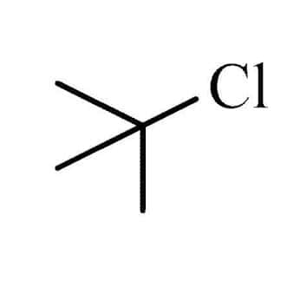

References:
L, Keller.; K, Joseph.; S, Miguel. CHEM 2081 Organic Chemistry 1 Lab Manual, Fall 2022 ed.

